The Efficacy of Machine Learning Techniques to Predict
Venous Thromboembolism After Trauma

by
Riley Thompson

A Master’s Thesis
Submitted to the Department of Bioinformatics and Computational Biology
at
The University of Minnesota in Rochester
For a Master’s Degree
Date Submitted

Table of Contents

Page
ACKNOWLEDGEMENTS……………………………………………………… 3
ABSTRACT……………………………………………………………………… 4
INTRODUCTION………………………………………………………………… 4
METHODS………………………………………………………………………... 5
Population…………………………………………………………………... 5
Data Collection……………………………………………………………... 6
Sample Collection…………………………………………………………. 6
Calibrated Automated Thrombogram Assay………………………………. 7
Machine Learning Techniques………………………………………...…… 8
RESULTS…………………………………………………………………………. 9
Sample Size………………………………………………………………... 9
Machine Learning Models………………………………………………… 9
DISCUSSION...…………………………………………………………………. 11
REFERENCES…………………………………………………………………... 14

Acknowledgements

This research would not have been possible without the support of Dr. Myung Park. Her guidance and generosity have aided me considerably. I also would like to thank Dr. Kia Khezeli and Dr. John Kalantari. They assisted me in creating and analyzing the machine learning models used in this study.

ABSTRACT
Venous Thromboembolism (VTE) is a blood clot that forms in the veins and encompasses both pulmonary embolism (PE) and deep vein thrombosis (DVT). This study aims to improve the existing predictive model for VTE after trauma first developed by Park et al.⁴ by incorporating machine learning and neural network models such as support vector machines, decision trees, random forests, and multi-layer perceptron classifiers. With the help of predictive modeling the long-term goal is to develop an algorithm that clinicians can use to better risk stratify patients for 90-day VTE risk following traumatic injury. VTE is a significant contributor to morbidity and mortality after injury. Having a high rate of true positive predictions will lead to a lower rate of VTE development as better risk stratification will enable more aggressive chemoprophylaxis.
INTRODUCTION
According to the CDC⁷, approximately 900,000 people in the United States will be affected by VTE every year. They also estimate that about 60,000 – 100,000 people will die because of VTEs within the same timeframe. Heit et al.⁶ estimated that approximately 12% of the patients acquiring a VTE occur following acute traumatic injury. However, VTE chemoprophylaxis (prophylactic dose heparin or Enoxaparin) cannot be offered immediately to all trauma patients due to an increased risk of developing bleeding complications in these patients. Currently it is recommended to start all trauma patients on chemoprophylaxis within 24 hours of hospital admission due to their VTE risk. However, the proportion of patients who can receive early chemoprophylaxis is relatively low, due to frequent high-risk injuries such as head injuries, fractures, and solid organ injuries. The mechanism behind VTE development following trauma are incompletely understood and few models exist to predict which trauma patients are at greatest risk for potentially devastating complication. This study looks to improve upon a model published by Park et al.⁴ which looks at predictor of 90-day VTE risk after trauma by using machine learning techniques such as support vector machines, decision trees, random forest, and neural network classifiers. Thanks to the generosity of Dr. Park, the models used in this study will be a direct comparison of the model previously published by Dr. Park’s team⁴. The data used to create the machine learning models is the same prospectively collected data used by Dr. Park when creating the original model. An improved predictive model would greatly assist in the prevention and early detection of VTEs in trauma patients.
METHODS
Population
This study’s population considered all Level 1 or 2 trauma patients transported to the Mayo Clinic Emergency Department by ambulance or air transport between February 2011 thru June 2014. Dr. Park is continuing patient enrollment and data collection as of the time this report was written, but the population included in this study will only use data collected between February 2011 and June 2014. The exclusion criteria for this study include history of Venous Thromboembolism (VTE), children less than 18 years of age, anticoagulation (e.g., heparin or warfarin), antithrombotic therapy (excluding aspirin or non-steroidal anti-inflammatory drugs), preexisting coagulopathy, no blood draw within 12 hours of injury, active cancer, sepsis, renal failure, burn injuries, or declined consent by the patient or guardian.
Level 1 trauma is defined as a patient with either respiratory distress, flail chest, heart rate greater than 120, systolic blood pressure less than 90, transfer patients who are receiving blood to maintain vitals, intubated patients, paralysis, spinal cord injury, unstable pelvic fracture, bilateral femur fracture, amputation, mangled or pulseless extremity, patients with tourniquets, electrocution, gunshot wound above the knee proximal to the elbow, intracranial bleeding, Glasgow Coma Scale less than 12, or skeletal muscle oxygen saturation less than 70%. Level 2 trauma is defined as a patient with long bone fractures, major auto deformity, auto vs pedestrian/bicyclist/motorcyclist with major impact, ejection from a moving vehicle, death of a restrained individual in the same vehicle, fall over 20 feet, or a suspected brain injury.
Data Collection
The time of injury (TOI) was based on the information provided by the pre-hospital medical providers based on the information provided at the site of injury. If the TOI was unclear, the pre-hospital medical providers estimated the TOI and provided this estimation to the emergency communication center. The patient’s demographics, baseline, injury severity score (ISS), trauma injury severity score (TRISS), age, sex, body mass index (BMI), length of stay in the hospital (LOS), the start and stop time of thromboprophylaxis and other coagulation affecting medications, all injury codes from the Mayo Clinic Trauma Registry, transfusion data, IVC filter placement, and standard laboratory data were all collected and recorded.
The patient’s VTE status was monitored for 90 days after hospital discharge. The frequent follow-up discontinued when the patient had a diagnosed VTE, death, or other loss to follow-up. The development of deep vein thrombosis (DVT) or pulmonary embolism (PE) both constitute a diagnosis of VTE. The goal of this study is to use thrombin generation data gathered using Calibrated Automated Thrombogram (CAT; Thrombinoscope BV, Maastricht, The Netherlands) assay to predict the development of VTE within 90 days after a traumatic injury.
Sample Collection
For the study, peripheral blood samples were collected from patients at baseline (0-2 hours), 6 hours, 12 hours, day 1 and day 3 after injury, and once upon hospital discharge. The blood was stored until written informed consent could be given. If patients were unable to provide consent at the time of trauma, consent was received from the patient or legal guardian within 30 days of leaving the hospital. If consent was declined or unable to be obtained, the samples would be discarded. Four 4.5 mL citrated Vacutainer tubes (0.105 M buffered sodium citrate, 3.2%; Becton Dickinson, Plymouth, UK) were collected by antecubital venipuncture or via an existing catheter. Within 1 hour of collection, the whole blood collections were processed to platelet-free plasma by double centrifugation at 3000g for 15 minutes as suggested by the ISTH vascular biology SSC Collaborative Workshop¹ and stored in several cryovials in -80°C freezers until the samples were pulled out of storage for analysis.
Calibrated Automated Thrombogram Assay
Plasma thrombin generation kinetics were measured using the CAT assay. A Fluoroskan Ascent plate reader (390 nm excitation, 460 nm emission; Thermo Electron Corporation, Vantaa, Finland) was used following Hemker et al.’s^{2,3} protocols and performed in a 96 well microplate. Each sample was run in triplicate. Corn trypsin inhibitor (20 mM Tris, 150 mM NaCl; Prolytix, USA) was added to each sample for a final concentration of 50 µg/ml before CAT analysis was performed. For each sample timepoint, 3 wells of the plate would be filled with 20 µL PPP (5 pM tissue factor and 4 µM phospholipid; Stago, USA) and 3 wells would be filled with 20 µL of thrombin calibrator (product number: 86192; Stago, USA). Afterward, 80 µL of citrated platelet free plasma (PFP) was added to each well for a total of 100 µL in each well. PPP contains tissue factor and is used to trigger thrombin generation and the thrombin calibrator is used to correct for inner filter effects and quenching variation between wells. The wells were then incubated for 10 minutes at 37°C. After the incubation period, 20 µL of FLUCA reagent (Fluca kit, TS50; Thrombinoscope, BV), previously warmed in a water bath to 37°C, was added to each well using an automated dispenser installed in the Fluoroskan Ascent. The FLUCA reagent contains the fluorogenic substate and CaCl₂. Thrombin generation begins as soon as the FLUCA reagent is added to the wells. Thrombin generation was then measured continuously over 90 minutes at a rate of 3 readings per minute. The software, Thrombinoscope (Thrombinoscope Analysis, ver. 3.0.0.29; Thrombinoscope, BV), was used to calculate the thrombin generation parameters. The parameters of interest are lagtime (LT), time to peak (ttPeak), peak height (PH), and endogenous thrombin potential (ETP). LT is the time between the addition of the FLUCA reagent and the initiation of thrombin generation. The ttPeak is the time it takes to get to the highest rate (peak) of thrombin generation. PH measures the highest rate of thrombin generation at a given point during the assay. And ETP is the area under the curve and measures total thrombin generation.
Machine Learning Techniques
In Park et al.’s 2017 paper⁴, the team used Kruskal-Wallis and Fisher’s exact tests to compare the variables between VTE cases and cohort members. The variables determined to be significantly linked to VTE were increasing patient age (p < 0.0001), BMI ≥ 30 kg/m² (p < 0.0001), surgery that required general anesthesia (p = 0.0003), ttPeak (p < 0.0001), ISS (p < 0.0001), and IVC filter after trauma (p < 0.0001). Although all these variables are significant to VTE, only some of these variables were used in the multivariable Cox proportional hazard regression. The variables used in the Cox regression were age, BMI ≥ 30 kg/m², surgery that required anesthesia, and time to peak value. This is because these variables are readily available and obtainable within the first 24 hours of admission to the hospital. These are the only four variables used when creating the machine learning models for this study. The C-statistic of Park et al.’s Cox regression model was calculated to be 0.799 (95% CI: [0.686, 0.822]). By applying machine learning to the same variables, we hope to improve upon Park et al.’s Cox regression model. The machine learning techniques used are support vector machines with a radial basis kernel, random forest classification, and gradient boosted decision trees. These models were then analyzed using receiver operator characteristic (ROC) curves and compared to the original Cox regression model by comparing the C-statistic or area under the ROC curve. We also used a neural network model from the Scikit Learn package in Python called MLPClassifier. The MLPClassifier is a supervised classifier that trains using backpropagation and multiple layers.
RESULTS
Sample Size
Of the 2,954 patients screened for the study between February 2011 and September 2015, 1,960 met study inclusion criteria. Of those individuals, 1,234 consented to be on the study. Of all the patients who consented to the study, 83 developed a VTE resulting in an imbalance between the VTE cases and the cohort cases. Therefore, 370 patients, representative of the full cohort, were allocated to be in the cohort arm of the study and the 83 patients developed a VTE after trauma and were placed in the VTE arm of the study. There is still an imbalance of cohort to VTE cases, but this imbalance can be alleviated by weighting VTE cases greater than the cohort cases during the analysis. Of the 83 patients who developed a VTE after trauma, 11 of them developed a VTE in less than 24 hours and were considered to have nonpreventable VTE, one subject was missing BMI information, and another subject had no pre-heparin blood samples and was therefore excluded from the study. Of the subjects allocated to the cohort arm of the study, 13 did not have any further follow-up, 29 were missing BMI information, and two did not have any pre-heparin blood samples and were therefore excluded from the analysis. Therefore, the machine learning models were created using 70 subjects with VTEs and 326 cohort trauma subjects.
Machine Learning Models
The Scikit Learn (sklearn) library was used to create the machine learning models in Python version 3.9.7 and Matplotlib was used to create the ROC curves used to evaluate how well the models performed. Hyperparameter optimization was utilized to find the optimal set of parameters for all three machine learning models. 3-fold cross validation was used to test the performance of each model. Each split was divided into a training set and a test set. The training set consisted of 70% of the original data and the test side consisted of the remaining 30%. The splits were stratified to ensure that each split had the same ratio of VTE to non-VTE subjects. The models were evaluated based off their ROC curve area under the curve (or C-statistic). The accuracy, precision, and F1-score were also calculated for each model.
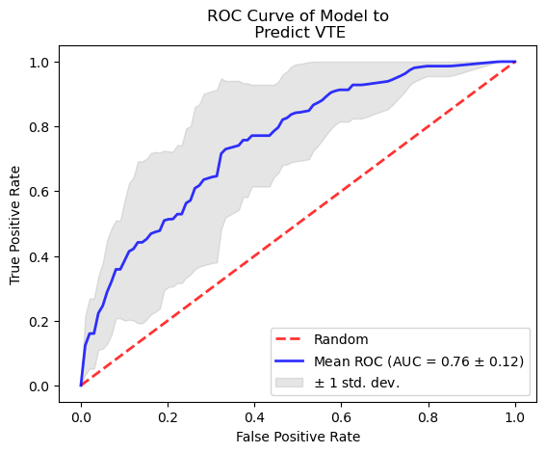
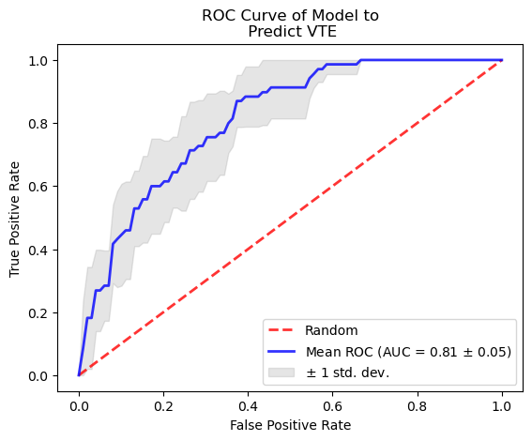
The model created from the support vector machine (SVM) with a radial basis kernel (as seen in Figure 1.) showed the highest promise. The area under the ROC curve was equal to 0.78 ± 0.05. This is very close to the C-statistic of the original Cox regression of 0.799 (95% CI: [0.731, 0.867]). The accuracy score with standard deviation of the SVM model is 0.72 ± 0.02, the average precision score is 0.42 ± 0.09, and the F1 score is 0.74 ± 0.02.
Figure 1. The ROC curve of the SVM model.
Figure 2. The ROC curve of the Gradient Boosted Decision Tree model.
______________________________________________________________________________________
The gradient boosted decision tree did not perform as well as the Cox regression model. Figure 2 shows the ROC curve of the gradient boosted decision tree model to predict VTE in trauma patients and the mean value of the area under the ROC curve was 0.72 ± 0.07. The average accuracy score and F1 score were both better than the SVM model with values of 0.82 ± 0.01 and 0.76 ± 0.02 respectively. The average precision score of the gradient boosted decision tree model was 0.38 ± 0.07, which is worse than the SVM model.
The random forest model performed the worst by far. The ROC curve can be seen in Figure 3 and shows the lowest area under the ROC curve with an average value of 0.71 ± 0.05. The average accuracy score of the model is 0.82 ± 0.02, the average precision score is 0.37 ± 0.07, and the F1 score shows a value of 0.78 ± 0.03. Despite this model performing poorly, the model still produced a better C-statistic than random chance.
The neural network approach with the MLPClassifier did not perform quite as expected. The accuracy of the model was good at 0.81 ± 0.02, but the area under the ROC curve is 0.76 ± 0.04, which is less than the SVM model. The precision score and F1 score are 0.39 ± 0.06 and 0.77 ± 0.03 respectively. I’m surprised that the neural network approach did not perform as effectively as the SVM approach. I had anticipated that with more iterations and backpropagations that the neural network approach would outperform all the models.
DISCUSSION
Park et al.’s study noted that an alarming 42% of all VTE cases that developed over the course of the study happened after hospital discharge. Another study by Godat et al.⁵ reported up to 45% of VTE diagnoses occur after discharge. This is incredibly alarming as follow-up does not normally go beyond the length of hospitalization. The hope of this study was to create a predictive model to classify patients who have a higher risk of developing VTE after trauma. This type of model would help clinicians determine who needs a prophylactic treatment to prevent future development of VTE after being discharged from the hospital.
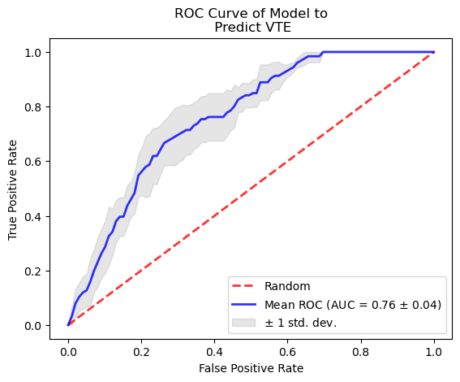
In a paper published by Christie et al.⁸, the team used a package in R called SuperLearner that would iterate through multiple algorithms such as logistic regression, linear regression, generalized additive models with various levels of smoothing, random forest, lasso, and systems based on sieves of parametric models to best predict mortality outcomes of new data. In one arm of their study, they had passed 212 variables of interest into SuperLearner in hopes of finding a non-generalizable model with high predictive power. This study also used random forests to determine variable importance in the prediction model using techniques developed by Breiman⁹ and Ishwaran¹⁰. They found that the Glasgow Coma Scale (GCS), Partial Thromboplastin Time, abbreviated injury (head), ISS, and age were the top variables that contributed to the prediction model. Introducing GCS and abbreviated injury (head) as variables in our models has the potential to greatly increase the accuracy of our predictions. The models would also benefit from a larger sample size.
______________________________________________________________________________________
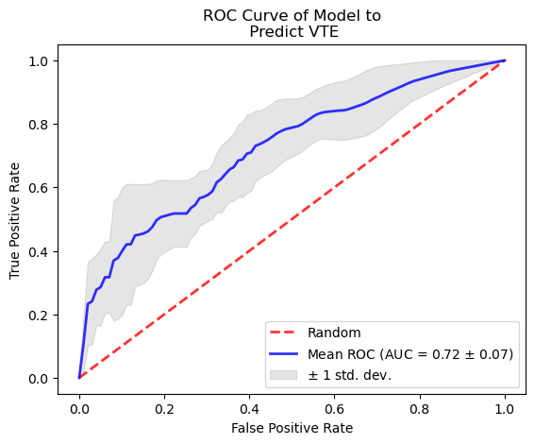
Figure 4. The ROC curve of the multi-layer peceptron model.
Figure 3. The ROC curve of the Random Forest model.
 | C-statistic (sd)
Cox Regression | 0.799 (0.068)
Support Vector Machine | 0.81 (0.05)
Gradient Boosted Decision Tree | 0.76 (0.12)
Random Forest | 0.72 (0.07)
MLP Classifier | 0.76 (0.04)

Table 1. Summary of each model’s C-statistic.

REFERENCES
1. Lacroix R, Judicone C, Mooberry M. Standardization of pre-analytical variables in
plasma microparticles determination: results of the International Society on Thrombosis
and Haemostasis SSC Collaborative workshop. J Thromb Haemost. 2013;11:1190-1193

2. Hemker HC. Recollections on thrombin generation. J Thromb Haemost. 2008;6:219-226.

3. Hemker HC, Al Dieri R, De Smedt E, Beguin S. Thrombin generation, a function test of
the haemostatic-thrombotic system. Thromb Haemost. 2006;96:553-561.

4. Park M. Thrombin generation profiles as predictors of symptomatic venous
Thromboembolism after trauma: A prospective cohort study. J Trauma Acute Care Surg.
2017;83:381-387.

5. Godat LN, Kobayashi L, Chang DC, Coimbra R. Can we ever stop worrying about
venous thromboembolism after trauma? J Trauma Acute Care Surg. 2015;78(3):475-481.

6. J.A. Heit, W.M. O'Fallon, T.M. Petterson, C.M. Lohse, M.D. Silverstein, D.N. Mohr, L.J.
Melton III, Relative impact of risk factors for deep vein thrombosis and pulmonary
embolism: a population-based study, Arch. Intern. Med. 162 (2002) 1245–1248.

7. “Data and Statistics on Venous Thromboembolism.” Centers for Disease Control and
Prevention, Centers for Disease Control and Prevention, 9 June 2022,
https://www.cdc.gov/ncbddd/dvt/data.html.

8. Christie, S. A., Hubbard, A. E., Callcut, R. A., Hameed, M., Dissak-Delon, F. N., Mekolo, D., Saidou, A., Mefire, A. C., Nsongoo, P., Dicker, R. A., Cohen, M. J., & Juillard, C. (2018). Machine learning without borders? an adaptable tool to optimize mortality prediction in diverse clinical settings. Journal of Trauma and Acute Care Surgery, 85(5), 921–927. https://doi.org/10.1097/ta.0000000000002044

9. Breiman L. Random Forests – Random Features. Berkeley, CA: Department of Statistics, University of California; 1999

10. Ishwaran H. Electron J Stat. 2007;519-537. Variable importance in Binary regression trees and forests.

